Assessor: |  | G. Mudare
Moderator: |  | D. Sundire
Instructions. If any of the instructions are disobeyed, candidates shall expose themselves to disqualification from future examinations.
General: No instructions or directives of the invigilator shall be disregarded; if any of the instructions are disobeyed, candidates shall expose themselves to disqualification from future examinations.
General: This is an individual examination. All work must be done on your own.
General: Candidates are expected to maintain academic integrity. Any form of plagiarism or cheating will be taken seriously and may result in disciplinary action including disqualification from future examinations.
General: No explanation of the examination questions may be asked or shall be given.
General: Late submissions will not be accepted without proof.
General: Candidates shall not communicate or attempt to communicate with anyone, and candidates shall not conduct themselves in an improper or unseemly manner.
General: Should any work need to be uploaded, ensure naming conventions are followed as instructed.
Practical: Please save and submit only one Power BI (.pbix) file, one R script (.Rmd) file, and one neatly knitted document. This is a practical paper, so ensure that all work is consolidated into these three files for submission.
Practical: Calculators may not be used during this examination.
Technical: Any technical issues must be reported to the invigilator immediately.

Section A Data Analysis Using R [Practical]:
Question 1: |  |  | Subtotal: |  | [7]
Write and execute R code to achieve the following:
- Find 10. random numbers between 0 and 100, rounded to the nearest whole number |  |  |  |  | [1]
- List all the lower case letters of the alphabet |  |  |  |  | [1]
- What is the 18th letter of the alphabet?  - What is the last letter of the alphabet |  |  |  |  | [1]
- Generate a random subset of fifteen letters.  - Are any letters in the subset duplicated?  - Tells us the index of the letters that are duplicated  - Tells us the actual letters that are duplicated |  |  |  |  | [2]
- Two vectors x and y contain the numbers 1,2,5,9,11 and 2,5,1,0,23  - Find values that are contained in both x and y  - Find values that are in x but not y (and vice versa). |  |  |  |  | [2]
Question 2 |  | Subtotal: |  |  | [15]
Write and execute R code to achieve the following:
- Read in the cereal dataset and inspect the data types of the variables in the dataframe |  |  |  |  | [1]
- Add a new variable to the dataset called ’totalcarb’, which is the sum of ’carbo’ and ’sugars’. |  |  |  |  | [1]
- How many cereals in the dataframe are ’hot’ cereals? |  |  |  |  | [1]
- How many unique manufacturers are included in the dataset? |  |  |  |  | [1]
Show records with only the Manufacturer ’K’.  List all cereals that have less than 80 calories, AND have more than 20 units of vitamins. |  |  |  |  | [1]
- Show records containing cereals that contain at least 1unit of sugar, and keep only the variables ’Cereal.name’, ’calories’ and ’vitamins’. Then inspect the first few rows of the file Sample result  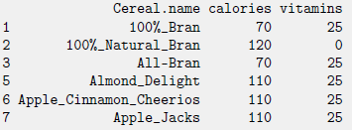 |  |  |  |  | [2]
- For one of the above record, write a new CSV file to disk. Submit the file. |  |  |  |  | [1]
- Rename the column ’Manufacturer’ to ’Producer’ |  |  |  |  | [1]
- Add a new variable ’SodiumClass’, which is ’high’ when sodium >. and ’low’ otherwise. Make  sure the new variable is a factor.  Now, find the average, minimum and maximum sugar content for ’low’ and ’high’ sodium. |  |  |  |  | [1]
- Find the maximum sugar content by Manufacturer and sodiumClass, using tapply. Inspect the  result and notice there are missing values. |  |  |  |  | [1]
- Produce a simple boxplot showing the distribution of sodium for each level of Manufacturer. |  |  |  |  | [1]
- Redraw the plot with Manufacturer in order of increasing mean sodium content |  |  |  |  | [2]
- Create a subset of data where the Manufacturer has at least two observations |  |  |  |  | [1]
Question 3 | subtotal |  |  |  | [17]
Write and execute R code to achieve the following:
From R’ s MASS package, you are provided with the Aids2 dataset that contains Australian AIDS Survival Data on patients diagnosed with AIDS in Australia before 1 July 1991

The following are the attributes:
state Grouped state of origin: "NSW "includes ACT and "other" is WA, SA, NT and TAS.
sex Sex of patient.
diag date of diagnosis.
death date of death or end of observation.
Status "A" (alive) or "D" (dead) at end of observation.
T.categ Reported transmission category.
Age Age (years) at diagnosis.

Do the following Analysis on the Data using R.
- Load the data into R |  |  |  |  | [1]
- Determine the class of the Dataset. |  |  |  |  | [1]
- Count or determine the number of records in the Data set |  |  |  |  | [1]
- Find the average age of people who had died of aids at the end of the observation. |  |  |  |  | [1]
- For all those that were diagnosed what was the major Transmission category? |  |  |  |  | [1]
- Find the mean and standard deviation of the first 15 diagnosed patients from the state of NSW. |  |  |  |  | [3]
- Show records for the unborn babies who were diagnosed with aids. |  |  |  |  | [1]
- Provide a report of those diagnosed patients Dead or Alive, who contracted aids neither through mother to child Transmission nor through blood. |  |  |  |  | [2]
- Show records for the oldest and youngest person(s) who died of aids. |  |  |  |  | [2]
- Determine using box plot the five-number summary of the Males and Females diagnosed with the disease. |  |  |  |  | [2]
- The ages between 15 and 55 are regarded as the most sexually active group, prone to contracting aids more than all the other age groups combined. Is this true?  Check, if this is true using a histogram visual representation. |  |  |  |  | [2]
Question 4 Modelling: |  |  |  | Subtotal | [17]
Using the attributes Age, state, sex, T.categ, and diag, write R code that performs the following:
- Data Preparation:  Convert any categorical variables into factors.  Split the data into training (70%) and test (30%) sets. |  |  |  |  | [2]
- Model Training:  Build a decision tree model to predict Status (either "A" or "D") using the rpart package. |  |  |  |  | [1]
- Decision Tree Model:  Use the rpart package to train a decision tree model to predict Status using Age, state, T.categ, sex, and diag as predictors. |  |  |  |  | [1]
- Plot the Decision Tree:  Use the rpart.plot package to create a clear, labelled plot of the decision tree.  Ensure the tree shows the split criteria and the probability for each class in each node. |  |  |  |  | [3]
- Model Evaluation:  Predict Status on the test set and display the confusion matrix.  Calculate the model's accuracy based on the test set predictions. |  |  |  |  | [3]
- Analysis:  Based on the confusion matrix and accuracy, discuss the model's performance. Suggest one possible improvement that could increase the model's accuracy. |  |  |  |  | [3]
- Create a new data frame for the following three previously unknown records with the same structure as the training data.  Apply the trained model to these new records to predict the Status. |  |  |  |  | [2]
 |  |  |  |  | [2]
  Age | State | T.categ | sex | diag
  35 | NSW | HSX | M | 1988-05-15
  47 | VIC | IDU | F | 1990-03-22
  29 | Other | BLOOD | M | 1989-07-10
Section B Data Analytics Using Power BI [Practical]:
Question 5: |  |  | Subtotal: |  | [44]
You are provided with a sales dataset for ABC corporation.
You are tasked with creating a comprehensive and interactive Power BI report to provide executive-level insights into company performance across various regions, products, and sales teams. Your report should span multiple pages, each focused on a different aspect of company performance, allowing executives to explore data dynamically and view high-level summaries, trends, and detailed drilldowns.

Note: Please check last page for additional information
Report Structure
Your report should contain the following pages, with each page focusing on specific visualizations, metrics, and analyses as outlined below: Each page must be named as given.
Page 1: Executive Summary  This page provides an overview of key company metrics, enabling quick insights into overall performance.  Include the following visualizations:  Key Metrics Summary Table showing the following metrics:  Total Sales,  Total Product Cost,  Total Quantity Sold,  Profit,  Profit Margin (%),  Sales Growth (%), and  Scorecard: Showcase Total Sales and Profit Margin (%),  Pie Chart: Show Sales Distribution by Product Category for a high-level view of which categories contribute most to total sales.  Slicers: Add slicers for Product Category, and Year to enable dynamic filtering across the page.  Your first page must look like the image below:  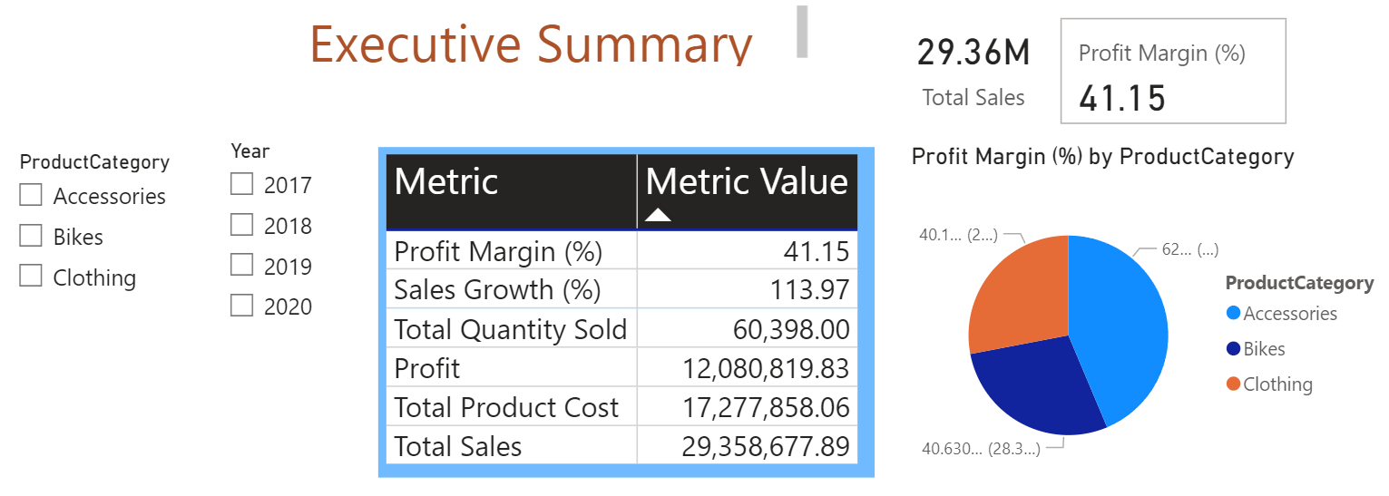 |  |  |  |  | [10]
Page 2: Sales Performance by Model  Focuses on individual Model performance, helping executives identify top Model sales contributions across all models.  Include the following visualizations:  Top 5 Models by Sales: Display a table showing Model, Total Sales, Total Quantity Sold, Profit, and Profit Margin (%).  Bar Graph: Represent Total Sales by Model, with emphasis on the top performers for comparison.  Drill through Button: Include a button to navigate to the Model Performance drill through page (Page 5), which provides detailed performance data for each model.  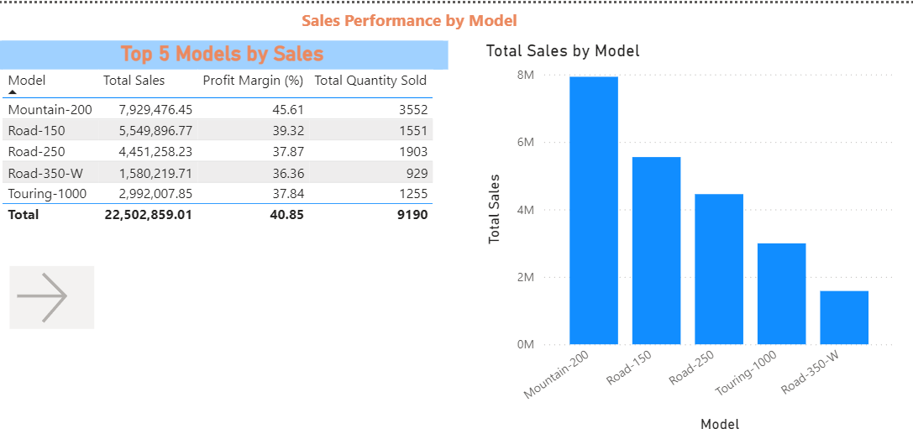 |  |  |  |  | [6]
Page 3: Product Performance  This page highlights the best-selling products and overall product-level performance, providing insights into product demand and profitability.  Include the following visualizations:  Top 5 Best-Selling Products: Display a table showing Product Name, Total Sales, Total Quantity Sold, Total Product Cost, Profit, and Profit Margin (%).  Pie Chart: Show Sales Distribution by Product for a visual breakdown of product popularity and contribution to total sales.  Bar Graph: Represent Total Sales by Product Category for insights into performance across different product types.  Sample  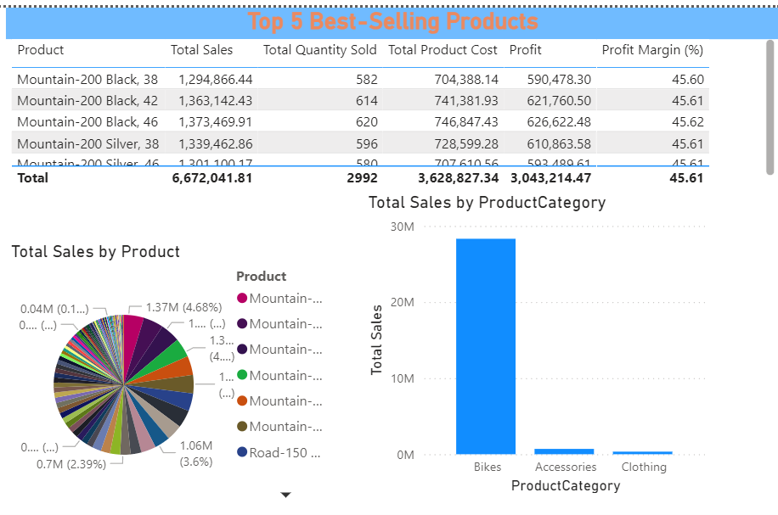 |  |  |  |  | [6]
Page 4: Regional Sales Analysis  This page provides a geographic view of sales distribution, helping executives analyze regional performance and sales growth.  Include the following visualizations:  Map Visualization: Use a map to display Total Sales by Country, with color saturation highlighting regions with higher sales.  Cumulative Sales Year-to-Date (YTD): A line chart that shows cumulative total sales from the beginning of the year, allowing tracking of sales progress over time.  Quarterly Sales Summary Table: Show quarterly sales totals along with Quarter-over-Quarter Growth (%) for an overview of quarterly performance changes.  Sample  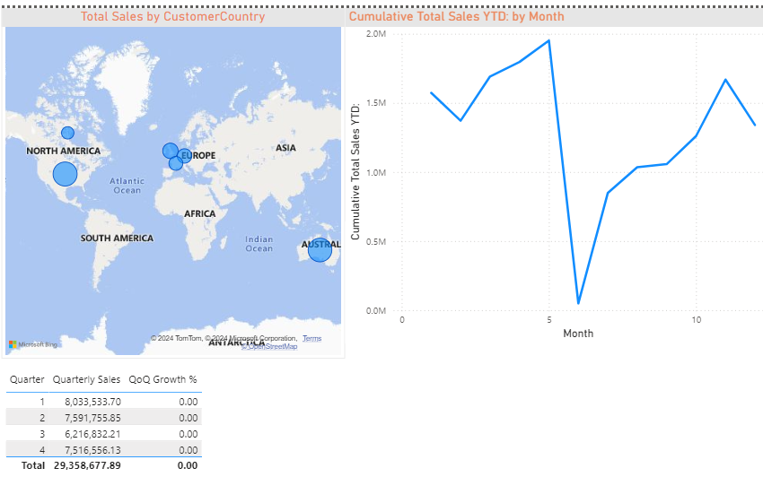 |  |  |  |  | [6]

Page 5: Model Performance Drill through A drill through page with detailed performance metrics for individual models. This page is accessible through the drill through button on Page 2.  Include the following visualizations:  Detailed Model Metrics Table:  Display data on Total Orders, Sales Amounts, and Profitability per Model in each Customer country.  Return to Page Button: Add a button to return to the Sales Performance by Model page.  Sample  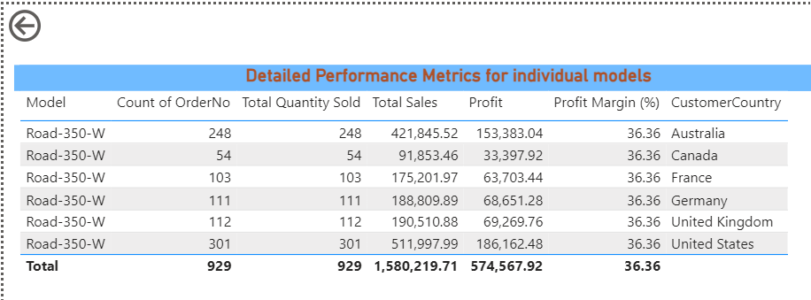 | [4]
Page 6: Time Intelligence Analysis  This page leverages time-based calculations to analyze sales trends over time.  Include the following visualizations:  Year-Over-Year Sales Growth (%): A KPI card displaying the percentage growth in Total Sales compared to the previous year.  Month-over-Month Sales Comparison: A bar chart displaying Total Sales by Month to highlight monthly trends and seasonality.  Tooltip with Line Chart: Implement a tooltip to display a line chart showing Total Sales each day for quick, detailed trend analysis.  Sample  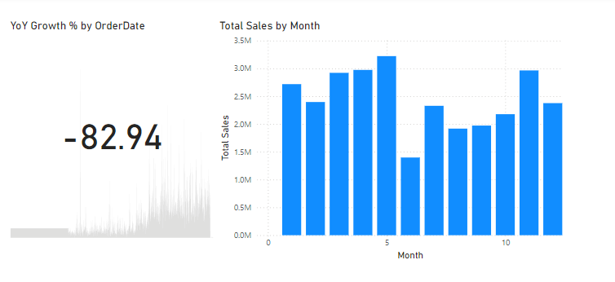 | [6]

Page 7: Report Navigation  A page dedicated to navigation options and role-based security demonstrations.  Include the following elements:  Bookmarks: Implement bookmarks for easy navigation between the main report views, including Executive Summary, Sales Performance by Model, Product Performance, Regional Sales, Time Intelligence Analysis, and Model Performance Drill through.  Sample  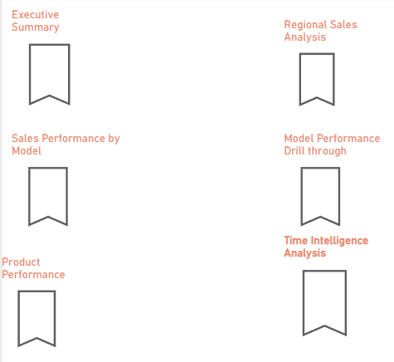 | [6]

Additional information on the calculation of key metrics
- Total Sales: Calculate the total revenue by summing up the prices of all items sold.
- Total Product Cost: Add up the costs associated with each item to get the overall cost of all products.
- Total Quantity Sold: Find the total quantity by adding up all items sold across different orders.
- Profit: Determine profit by subtracting the total product cost from the total sales revenue.
- Profit Margin (%): Calculate the profit margin by dividing the profit by total sales, then multiplying by 100 to get a percentage.
- Sales Growth (%): To find sales growth, subtract the previous year’s sales from the current total sales, then divide by the previous year’s sales and multiply by 100.
- Order Fulfillment Rate (%): Divide the number of completed orders by the total number of orders, then multiply by 100 to express as a percentage.
- Year-Over-Year Sales Growth (%): Determine the annual growth rate by subtracting the sales from the previous year from the current year's sales, then dividing by the previous year’s sales and converting to a percentage.
- Month-over-Month Sales Growth (%): Subtract the sales of the previous month from the current month’s sales, divide by the previous month’s sales, and multiply by 100 for a monthly growth percentage.
- Cumulative Total Sales Year-to-Date (YTD): Add up all sales from the start of the year until the current date to get the year-to-date cumulative sales.
- Rolling 3-Month Average Sales: Calculate the average sales over the last three months to smooth out short-term fluctuations. Use the total sales of each month, then divide by three.
- Quarterly Sales Total: Sum up sales across each quarter for a quarterly performance view.

